

Automated Support Infrastructure Remote ASI Client Scrip Configuration User Guide

Table of Contents

Introduction 3
Accessing the Scrip configuration function 3
Accessing Scrip configuration for one system 3
Accessing Scrip configuration for one site 5
Accessing Scrip configuration for a user defined group 5
Accessing Scrip configuration for all systems 6
Navigation note 7
ASI Scrip configuration 7
Checking the status of a Scrip configuration change 10
Exporting a Scrip configuration to other sites 14

Introduction
The Configuration module on the ASI server lets you configure any Scrip on any ASI client at any of the sites you manage, without having to be on site. The entire process takes no more than a couple of minutes for each Scrip configuration change. Scrip configuration changes can be exported from one system to one, some, or all sites you manage using a simple point-and-click procedure that takes no more than a couple of minutes.
This document is a step-by-step guide for changing the configuration of a Scrip using the Configuration module on the ASI server. It does not provide information and instructions changing the configuration parameters of all Scrip. Scrips’ configuration parameters and instructions for changing them are contained in Scrips’ configuration help files available online on the ASI server and accessed by clicking on the help link on the configuration navigation bar on a Scrip’s configuration page.
For additional information about the Configuration module on the ASI server, please refer to Automated Support Infrastructure Site Management User Guide.

Accessing the Scrip configuration function
You can access the Scrip configuration function from a variety of access points on your ASI server. In this section, we will describe all of these access points.

Accessing Scrip configuration for one system
You can access a system’s Scrip configurator from the following entry points:
- ASI Dashboard
- Log onto the ASI Dashboard (https://asiservername/main/dashbrd/dnav.php)
- In the left pane, locate and expand the entry for the site where the system whose Scrip you want to configure is located by clicking on the “+” icon to the right of the site name. The systems belonging to the site will be listed in the left pane below the site name and indented to the right.
- Click on the name of the system whose Scrip you want to configure. The Items for machine <machine name> page will be displayed in the right pane.
- Click on the manage link at the top of the right-pane display. The Scrip Configurator - Select Scrip - Site <site name> - Machine <machine name> page will be displayed.
Alternatively,
- Log onto the ASI Dashboard (https://asiservername/main/dashbrd/dnav.php)
- In the left pane, locate and expand the entry for the site where the system whose Scrip you want to configure is located by clicking on the “+” icon to the right of the site name. The systems belonging to the site will be listed in the left pane below the site name and indented to the right.
- Click on the name of the site where the system whose Scrip you want to configure is located. The Items for machine group <site name> page will be displayed in the right pane.
- Click on the manage link for the system whose Scrip you want to configure. The Scrip Configurator - Select Scrip - Site <site name> - Machine <machine name> page will be displayed.

- Census page
- Log onto the ASI server (https://asiservername/main ). The ASI dashboard will be displayed.
- Click on the Use extended interface link on the right side of the ASI Dashboard upper pane, below user login and date. The Welcome page will be displayed.
- At the upper right-hand corner of any page on the ASI server extended interface, click on the census link in the tools navigation bar (https://asiservername/main/acct/census.php). The Census - Sites page will be displayed.
- Locate the entry for the site where the system whose Scrip you want to configure is located, and click on its [machines] link. The Census - <site name> page will be displayed.
- Locate the entry for the system whose Scrip you want to configure, and click on its [manage] link. The Scrip Configurator - Select Scrip - Site <site name> - Machine <machine name> page will be displayed.
- Scrip configuration wizard
- Log onto the ASI server (https://asiservername/main ). The ASI dashboard will be displayed.
- Click on the Use extended interface link on the right side of the ASI Dashboard upper pane, below user login and date. The Welcome page will be displayed.
- At the upper right-hand corner of any page on the ASI server extended interface, click on the wizard link in the sites navigation bar (https://asiservername/main/config/index.php?act=wiz).
- Click on the Scrip configuration link (https://asiservername/main/config/scrpconf.php?custom=8). The Scrip Configuration - Select a Group page will be displayed.
- Click on the A single machine radio button. Then click on the Next button. The Scrip Configuration - Select Site page will be displayed.
- Locate the entry for the site where the system whose Scrip you want to configure resides, and click on its radio button. Then click on the Next button. The Scrip Configuration - Site <site name> - Select Machine page will be displayed.
- Locate the entry for the system whose Scrip you want to configure resides, and click on its radio button. Then click on the Next button. The Scrip Configuration - Select Scrip page will be displayed.
- Configuration module
- Log onto the ASI server (https://asiservername/main ). The ASI dashboard will be displayed.
- Click on the Use extended interface link on the right side of the ASI Dashboard upper pane, below user login and date. The Welcome page will be displayed.
- At the upper right-hand corner of any page on the ASI server extended interface, click on the configuration link in the sites navigation bar (https://asiservername/main/config/index.php?act=site ). The Select a Site page will be displayed.
- Locate the entry for the site where the system whose Scrip you want to configure is located, and click on its [view machines] link. The Configuration - <site name> Machines page will be displayed.
- Locate the entry for the system whose Scrip you want to configure, and click on its [configure Scrips] link. The Scrip Configurator - Select Scrip - Site <site name> - Machine <machine name> page will be displayed.

Accessing Scrip configuration for one site
You can access a site’s Scrip configurator from the following entry points:
- Scrip configuration wizard
- Log onto the ASI server (https://asiservername/main ). The ASI dashboard will be displayed.
- Click on the Use extended interface link on the right side of the ASI Dashboard upper pane, below user login and date. The Welcome page will be displayed.
- At the upper right-hand corner of any page on the ASI server extended interface, click on the wizard link in the sites navigation bar (https://asiservername/main/config/index.php?act=wiz).
- Click on the Scrip configuration link (https://asiservername/main/config/scrpconf.php?custom=8). The Scrip Configuration - Select a Group page will be displayed.
- Click on the A single site radio button. Then click on the Next button. The Scrip Configuration - Select Site page will be displayed.
- Locate the entry for the site where you want to configure Scrips, and click on its radio button. Then click on the Next button. The Scrip Configuration - Select Scrip - <site name> page will be displayed.
- Configuration module
- Log onto the ASI server (https://asiservername/main ). The ASI dashboard will be displayed.
- Click on the Use extended interface link on the right side of the ASI Dashboard upper pane, below user login and date. The Welcome page will be displayed.
- At the upper right-hand corner of any page on the ASI server extended interface, click on the configuration link in the sites navigation bar (https://asiservername/main/config/index.php?act=site ). The Select a Site page will be displayed.
- Locate the entry for the site where you want to configure Scrips, and click on its [configure site] link. The Scrip Configuration - Select Scrip - Site <site name> page will be displayed.

Accessing Scrip configuration for a user defined group
You can access a user defined group’s Scrip configurator from the following entry points:
- Scrip configuration wizard
- Log onto the ASI server (https://asiservername/main ). The ASI dashboard will be displayed.
- Click on the Use extended interface link on the right side of the ASI Dashboard upper pane, below user login and date. The Welcome page will be displayed.
- At the upper right-hand corner of any page on the ASI server extended interface, click on the wizard link in the sites navigation bar (https://asiservername/main/config/index.php?act=wiz).
- Click on the Scrip configuration link (https://asiservername/main/config/scrpconf.php?custom=8). The Scrip Configuration - Select a Group page will be displayed.
- Click on the A group of machines radio button. Then click on the Next button. The Scrip Configuration - Select A Group page will be displayed.
- Locate the entry for the group where you want to configure Scrips, and click on its [use] link. The Scrip Configuration - Select Scrip – Group <group name> page will be displayed.
- Group management module (only for groups you have created)
- Log onto the ASI server (https://asiservername/main ). The ASI dashboard will be displayed.
- Click on the Use extended interface link on the right side of the ASI Dashboard upper pane, below user login and date. The Welcome page will be displayed.
- At the upper right-hand corner of any page on the ASI server extended interface, click on the groups link in the tools navigation bar. The Select or Add a Group page will be displayed (https://asiservername/ main/config/groups.php?custom=3).
- Locate the entry for the user defined group where you want to configure Scrips, and click on its [configure Scrips] link. The Scrip Configuration - Select Scrip - Group <group name> page will be displayed.

Accessing Scrip configuration for all systems
You can access the Scrip configurator for all systems from the following entry points:
- Scrip configuration wizard
- Log onto the ASI server (https://asiservername/main ). The ASI dashboard will be displayed.
- Click on the Use extended interface link on the right side of the ASI Dashboard upper pane, below user login and date. The Welcome page will be displayed.
- At the upper right-hand corner of any page on the ASI server extended interface, click on the wizard link in the sites navigation bar (https://asiservername/main/config/index.php?act=wiz).
- Click on the Scrip configuration link (https://asiservername/main/config/scrpconf.php?custom=8). The Scrip Configuration - Select a Group page will be displayed.
- Click on the All machines radio button. Then click on the Next button. The Scrip Configuration - Select Scrip page will be displayed.

Note – Substitute asiservername with the name of the ASI server your sites log to.

Navigation note
Clicking on the Perform a management, maintenance, or support action link under the Take Action heading on the Welcome page, or on the configuration link to the right of the sites: label at the upper right-hand corner of any page on the ASI event management facility, will take you to the Select a Site page in the Configuration module.
Once you access the Configuration module of the ASI site management facility, a second level navigation bar, whose content varies depending on the task you are performing, appears on the page. For example, the second-level navigation bar on the Select a Site page is:
- configuration: status | sites
To get back to the Select a Site page from anywhere within the Configuration module, just click on the sites link on the second level navigation bar.

ASI Scrip configuration
The Scrip Configurator page for a system, a site, a user defined group, or all systems, reached after you perform one of the sequence of steps in the preceding section, is essentially the same. It consists of a list of Scrip entries. For example, below you will find a system’s Scrip Configurator page.

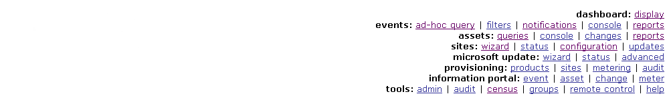
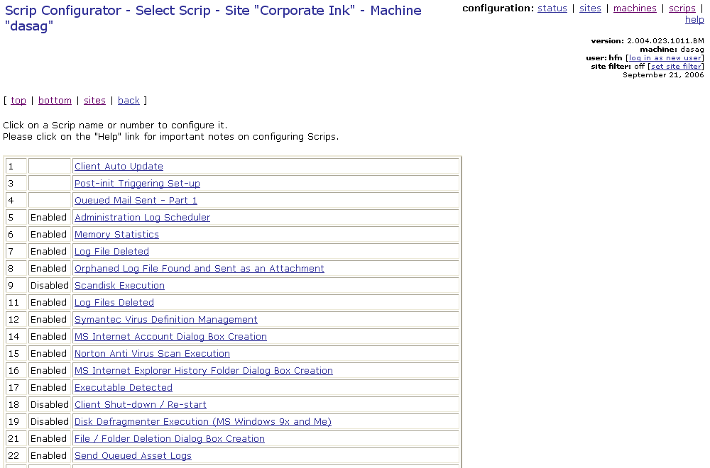
Once you have reached the Scrip Configurator page for a system, a site, a user defined group, or all systems, the steps you need to perform in order to configure a Scrip are the same:
- Scroll down the Scrip Configurator, page until the entry for the Scrip whose configuration you want to change is visible, and click on it. The Scrip’s configuration page will be displayed (See figure below for an example).

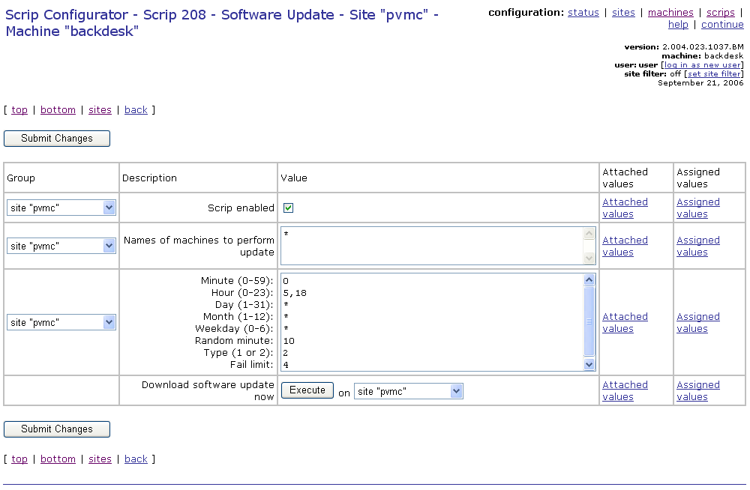
- Change the Scrip’s configuration (including clicking on Execute the button if you wish to run the Scrip on demand). The Changes recorded page will be displayed (See figure below).
If the Scrip configuration change you want to make applies only to the system whose Scrip configuration page you are viewing, as you change a Scrip’s configuration parameters make sure that for each parameter the system is selected from the Group pull-down list found to the left of the parameter name on the Scrip’s configuration page.
Please refer to Scrips’ configuration help files for detailed information about Scrips and their configuration. Scrip configuration help files are available online on the ASI server and accessed by clicking on the help link on the configuration navigation bar on a Scrip’s configuration page.

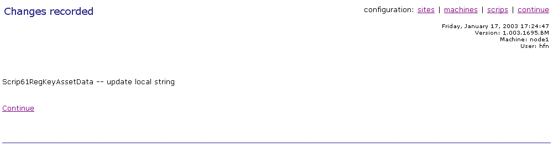
- The next time Scrip 177 (Scrip Configuration Update) from any of the ASI clients at the site where you changed one or more Scrip configurations contacts the ASI server, it will find the Scrip configuration changes you made (including command(s) to run one ore more Scrips on demand). If the Scrip configuration changes are site wide, It will download the changes, apply them to its system, and propagate them automatically to all systems at the site that are on the same sub-net.
If the Scrip configuration changes apply only to one system, not the system whose Scrip 177 contacted the ASI serve, the ASI client whose Scrip 177 contacted the ASI server will let the ASI client for which the Scrip configuration change is intended know that a Scrip configuration change for it is waiting on the ASI server. At that poiint, Scrip 177 from the system for which the Scrip configuration change was intended will contact the ASI server immediately.
By default, Scrip 177 is scheduled to run on each system at a site once per hour with a random minute interval of 50 (i.e. it will run within 50 minutes of its scheduled execution time). Please refer to the Automated Support Infrastructure Event Troubleshooting Guide for step-by-step instructions for changing Scrip 177’s configuration.
Please note that if the systems at the site where you made a global configuration change are on different sub-nets, Scrip 177 from at least one ASI client on one system from each sub-net will need to contact the Configuration module on the ASI server. Once that happens, the Scrip configuration changes will be processed on each sub-net as described above. For this reason, application of Scrip configuration changes to multi-sub-net sites may take longer than for single sub-net sites.

Checking the status of a Scrip configuration change
You can check the results of the Scrip configuration change you made after the Scrip whose configuration changed is executed (or which you ran on demand) by retrieving the event logs of the Scrip from the site where the Scrip configuration change was applied. To do this you need to access the Ad-hoc Event Query Form page and retrieve the Scrip’s event logs performing the following steps:
- Click on the Look at system events link under the View Information heading on the Welcome page, or on the ad-hoc query link to the right of the events: label at the upper right-hand corner on any page on the ASI management server. The Ad-hoc Event Query Form page will be displayed (See figure below).

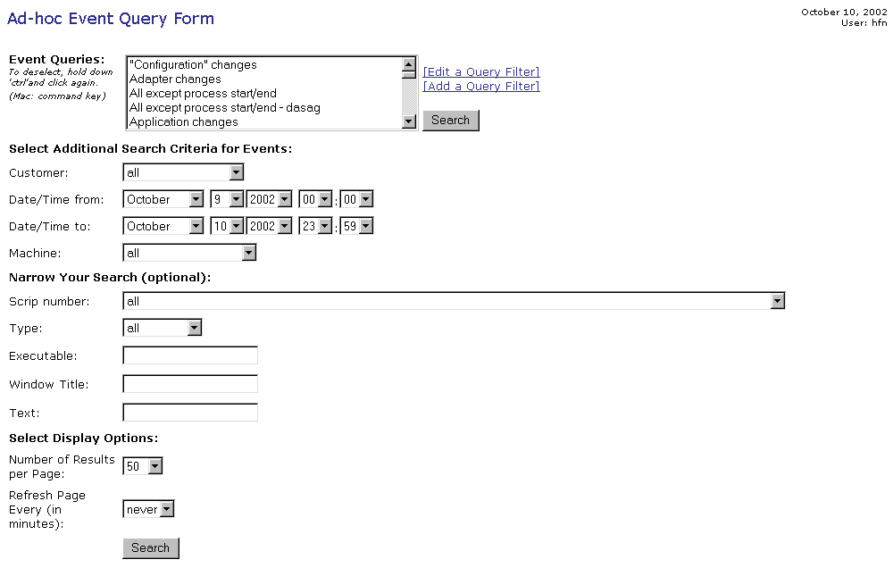
- On the Ad-hoc Event Query Form page, from the Customer pull down list select the name of the site where you made the Scrip configuration change (or ran the Scrip on demand).
- From the Scrip number pull down list, click on the entry for the Scrip whose configuration you changed (or which you ran on demand).
- Assuming that you are running the event query on the same day the Scrip whose configuration change you made was executed (or which you ran on demand), you do not need to change the Date/Time from: and Date/Time to: values, or enter/select a value for any of the other query parameters.
Alternatively, you can select values for the Date/Time from: and Date/Time to: parameters that correspond to the time interval when the Scrip whose configuration was changed was executed (or which you ran on demand).
- Click on the Search button. The Query Results page will be displayed (See figure below).
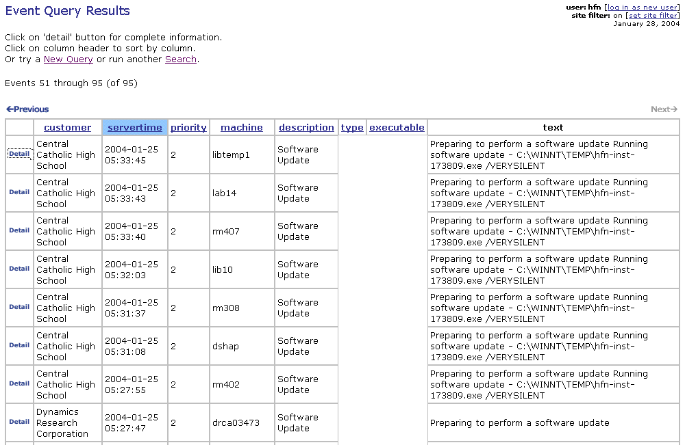
- Clicking on the Detail button will take you to the Event Detail page of the event log of the Scrip whose configuration changed (See figure below).
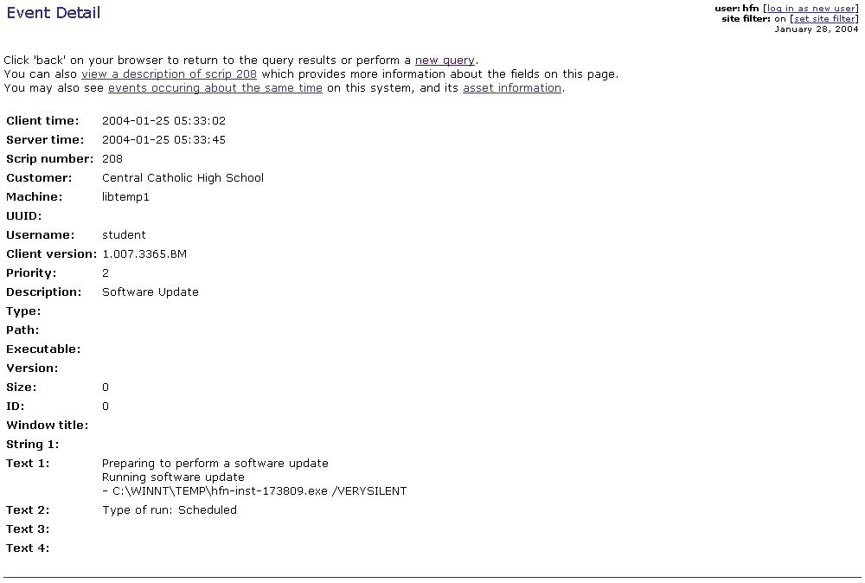
The content of each entry in the Event Detail page varies depending on the Scrip that was triggered by the event. Please refer to the Event Detail page help files for a description of each Scrip’s detail page. You can access them directly from Event Detail page by clicking on the view a description hyperlink.
Clicking on the events occurring about the same time link will take you to a page that lists the events that took place on the system in question within an interval of +/- ten minutes.
Clicking on the asset information link will take you the Asset Detail page of the system whose ASI client reported the event.
In Scrips 38 (Processor Fault), 77 (Windows Event Log Changes), and 94 (Dialog Boxes), you will also find the link knowledge base.
Clicking on this link automatically generates a page with a number of pre-built searches of the Microsoft knowledge base, World Wide Web searches and Usenet group using the text reported in the event log. Please refer to the Automated Support Infrastructure (ASI) Support Query Module User Guide for detailed information on this function.

Exporting a Scrip configuration to other sites
Once you have changed a Scrip’s configuration at one site, you may want to apply the same configuration change to one or more other sites. We call this exporting a Scrip’s configuration.
Please note that:
- You can export only site wide Scrip configuration changes
- You can only export entire Scrip configurations, not individual elements of a Scrip configuration.
- You can export multiple Scrip configuration changes at one time.
To export Scrip configuration changes, perform the following steps:
- Log onto the ASI server (https://asiservername/main ). The ASI dashboard will be displayed.
- Click on the Use extended interface link on the right side of the ASI Dashboard upper pane, below user login and date. The Welcome page will be displayed.
- Click on the Perform a management, maintenance, or support action link under the Take Action heading on the Welcome page, or on the configuration link in the sites navigation bar (https://asiservername/main/config/index.php?act=site ). The Select a Site page will be displayed.
- Once you access the Configuration module of the ASI site management facility, a second level navigation bar, whose content varies depending on the task you are performing, appears on the page. For example, the second-level navigation bar on the Select a Site page is:
- configuration: status | sites
To get back to the Select a Site page from anywhere within the updates module, just click on the sites link on the second level navigation bar.
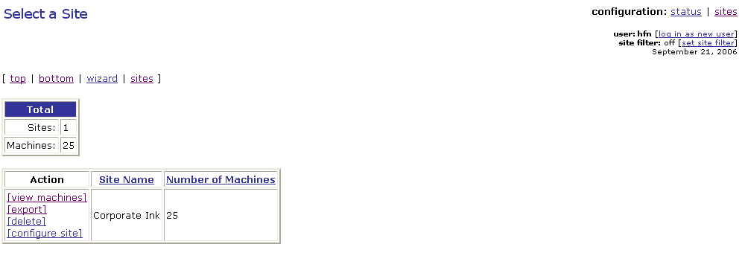
- Click on the [view machines] link to the left of the entry for the site where you want to configure one or more Scrips. The site’s Configuration - <site name> Machines page will be displayed (See figure below)

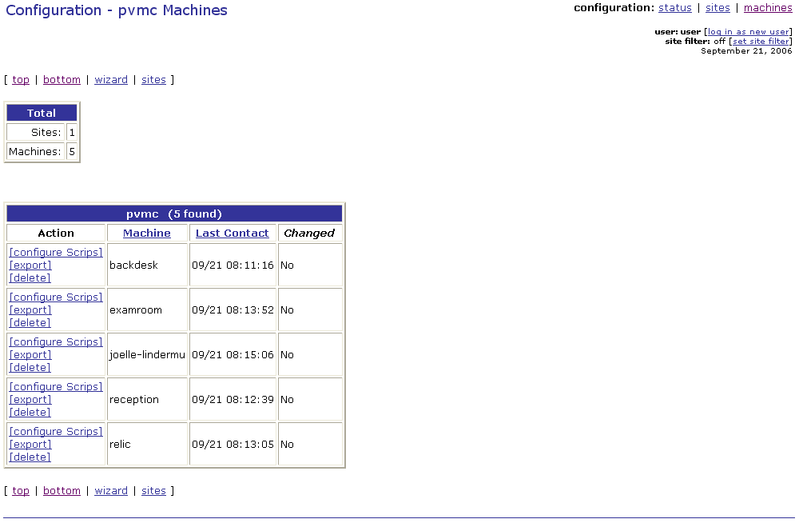
- Click on the [export] link to the left of the entry for any system. The Export Global Scrip Configurations page will be displayed (See figure below).
Please note that alternatively you could have clicked on the [export] link to the left of the entry for the site where you made the Scrip configuration change on the Select a Site page.

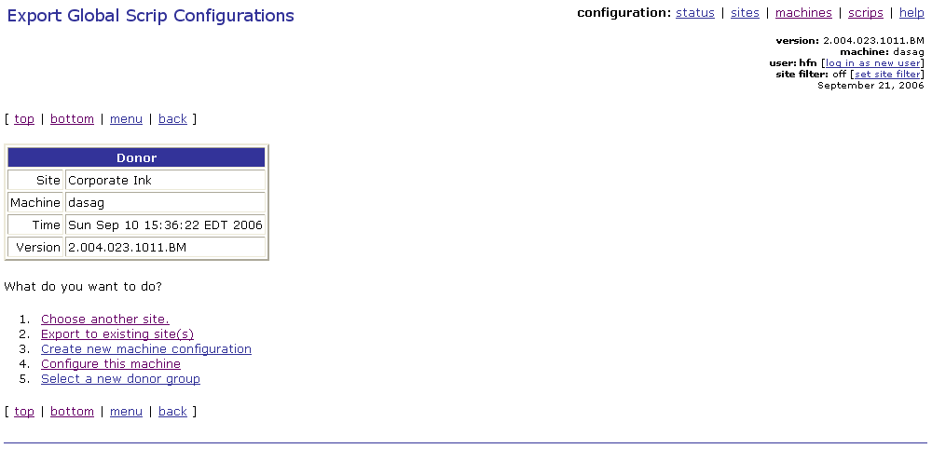
- On the Export Global Scrip Configurations page, click on the Export to existing site(s) link. The Export to Specified Sites page will be displayed, as shown below.

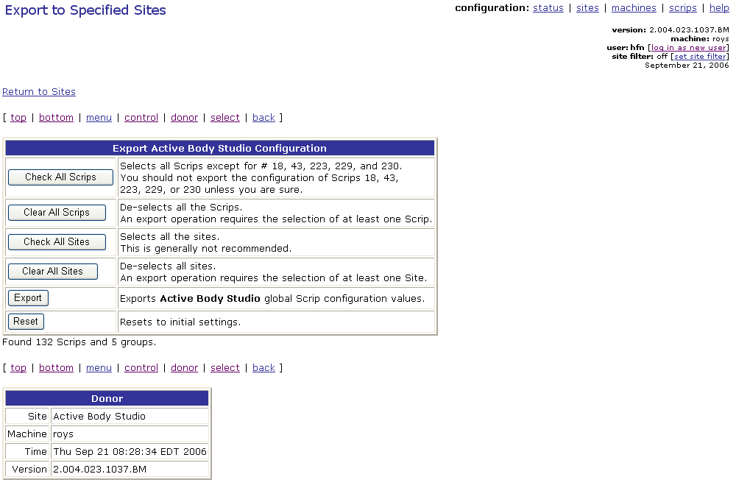
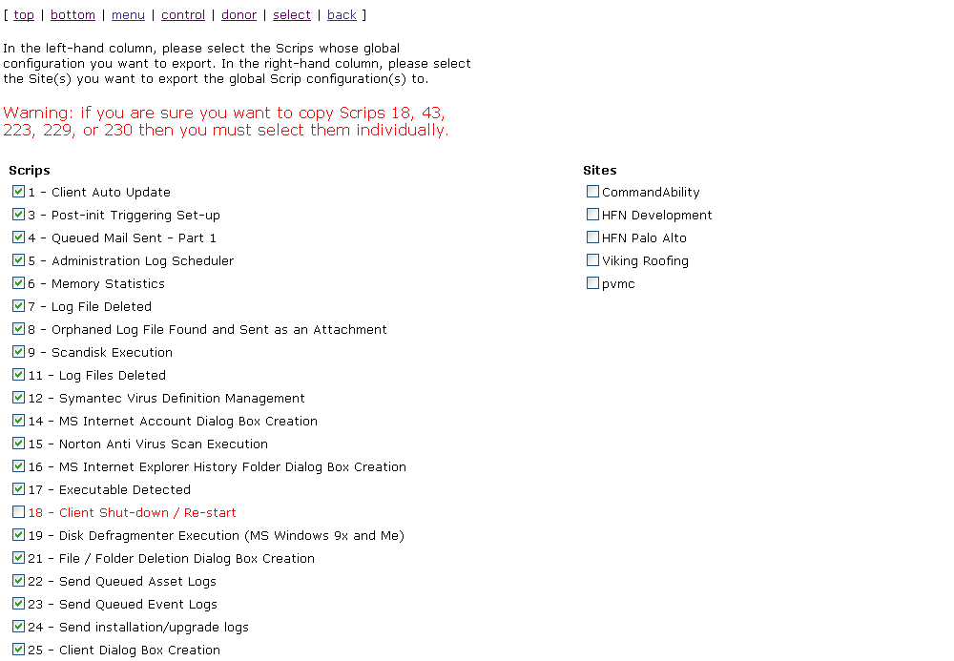

- Click on the Clear All Scrips button in the Export <Site Name> Configuration control panel at the top of the Export to Specified Sites page.
- Scroll down to the detail area of the Export to Specified Sites page where all available Scrips and sites are listed.
- Click on the check box to the left of the entry for the Scrip(s) whose configuration you want to export.
- Click on the check box to the left of the entry for the site(s) whose configuration you want to export.
Please note that if you want to export Scrip configuration change(s) to all sites, instead of clicking on the check box for each site, you can simply click on the Check All Sites button in the Export <Site Name> Configuration control panel at the top of the Export to Specified Sites page.
- Click on the Export button in the Export <Site Name> Configuration control panel at the top of the Export to Specified Sites page.

